

**REPUBLIC OF KENYA**

**MINISTRY OF ENVIRONMENT, CLIMATE CHANGE AND FORESTRY**

**KENYA METEOROLOGICAL DEPARTMENT**

*Dagoretti Corner, Ngong Road, P. O. Box 30259, 00100 GPO, Nairobi, Kenya*

***Telephone:*** *254 (0) 20 3867880-7,* ***Fax:*** *254 (0) 20 3876955/3877373/3867888,*

***E-mail:*** *director@meteo.go.ke,* ***info@meteo.go.ke****;* ***Website:****http://www.meteo.go.ke*

Biometeorological Services Division

# **WEEKLY BIOMETEOROLOGICAL BULLETIN (18TH FEBRUARY –24TH FEBRUARY 2025)**

|  |  |  |  |
| --- | --- | --- | --- |
| |  | | --- | | **Ref No: MET/7/58/2-2025** | | |  | | --- | | **Issue Date: 17/02/2025** | |

**PREAMBLE**

Biometeorology is an interdisciplinary science of interactions between atmospheric processes and living organisms - plants, animals and human-beings. The Biometeorological Services Division collects, analyzes and interprets Meteorological and Health data in liaison with partners in the Health Sector for advisory development.

The weather information provided is aimed at guiding residents to identify and recognize the likelihood of occurrence of weather-related health diseases according to the issued advisories and take necessary action.

**SUMMARY**

We are experiencing a general increase in temperatures, which may lead to heat stress, dehydration, and other health risks. As per biometeorology advice, please take the following precautions:

**Stay Hydrated** – Drink plenty of water and avoid excessive caffeine or alcohol.

**Limit Outdoor Activities** – Avoid strenuous work during peak heat hours (10 AM – 4 PM).

**Dress Appropriately** – Wear light, loose-fitting, and breathable clothing.

**Keep Indoors Cool** – Use fans, ventilate rooms, and avoid unnecessary heat sources.

**Check on Vulnerable Groups** – The elderly, children, and those with health conditions need extra care.

**REVIEW FOR PREVIOUS WEEK (10TH - 16TH FEBRUARY 2025)**

**1.1 Rainfall**

Throughout the **7 days**, various stations experienced rainfall amounts not exceeding **50mm** total rainfall. All stations recorded less than **50mm** total weekly rainfall.

**1.2 High Temperatures**

This section lists stations that recorded average temperatures exceeding **35°C** in the last **7 days**. Temperatures in some counties including Lodwar, Wajir, Garissa, and Mandera recorded average weekly temperatures exceeding **35°C** as shown in Table 1 below.

**Table 1:**

|  |  |
| --- | --- |
| **Station** | **Average weekly maximum temperature** |
| Lodwar Met | 37.7°C |
| Mandera Met | 37.4°C |
| Wajir Met | 37.2°C |
| Garissa Met | 36.3°C |

**1.3 Low Temperatures**

This section lists stations that recorded average temperatures below **10°C** in the last **7 days**. Conversely, stations such as Nyandarua (Nyahururu) Nakuru, and Laikipia recorded lower temperatures, but, only Nyahururu recorded an average weekly temperature below **10°C** as shown in Table 2 below.

**Table 2:**

|  |  |
| --- | --- |
| **Station** | **Average weekly minimum temperature** |
| Nyahururu Met | 6.9°C |

**1.4 High Winds**

This section list stations that recorded winds with speeds of more than **25 knots (12.9 metres per sec)** in the last 7 days. This was recorded in **Marsabit,** and **Moyale**

**2.0 FORECAST FOR (18TH – 24TH FEBRUARY 2025)**

1. **Rainfall**

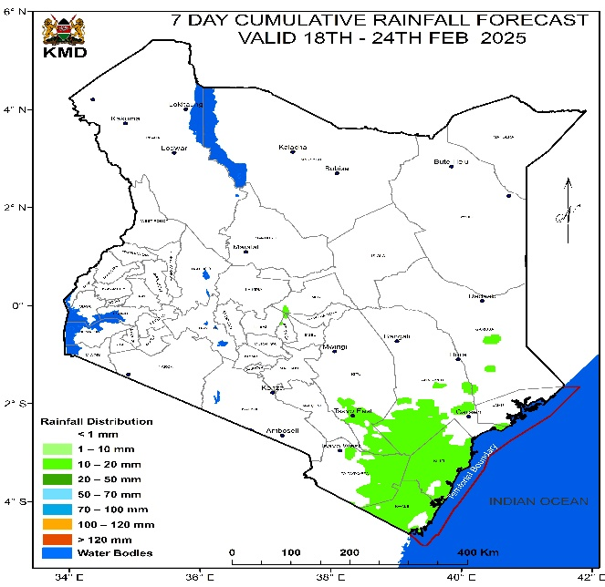

Rainfall amounts not exceeding **50mm** is to be expected over parts of the Country during the forecast period of Tuesday 18th February 2025 to Monday 24th February 2025. Rainfall of about **10 to 20 mm** are to be expected in counties like **Kwale, Kilifi, Taita Taveta and Tana River Counties.**

1. **High Temperature**

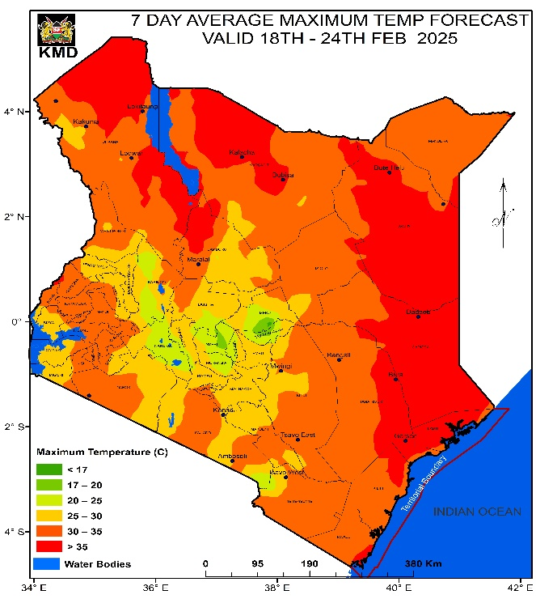

Temperatures exceeding **35°C** is to be expected in parts of **Lodwar, Garissa, Wajir, Mandera, Lamu Marsabit, and Turkana Counties** during the forecast period of Tuesday 18th February 2025 to Monday 24th February 2025.

1. **Low Temperature**

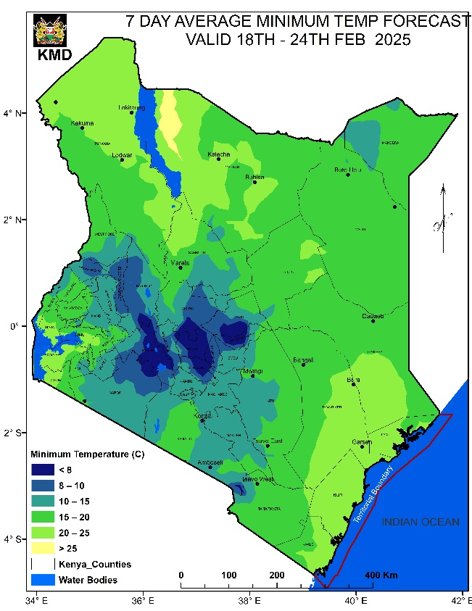

Temperature of less than **10°C** is expected over Counties like **Nakuru, Nyeri, Muranga, Tharaka Nithi, Kajiado, Baringo, Nyandarua (Nyahururu), Taita Taveta, Narok, Meru,** and **Laikipia** during the forecast period of Tuesday 18th February 2025 to Monday 24th February 2025.

1. **Winds**

Winds of more than **25 knots (12.9m/s)** are expected over parts of **Marsabit**, **Mombasa, Kilifi (Mtwapa, Msabaha, Malindi), Wajir, Mandera, Turkana, Lodwar,** and **Lamu Counties**

during the forecast period of Tuesday 18th February 2025 to Monday 24th February 2025.

**3.0 Meteorological Advisory on Weather-Related Risks**

Residents are encouraged to monitor the following weather conditions and their potential impacts:

**1. Heavy Rainfall**

- Forecast: Areas expected to receive over **50 mm** of rainfall weekly may experience significant water accumulation.

- Implications: This can lead to flooding and increased risks of waterborne diseases.

- Recommendation: Ensure proper drainage systems are in place and stay informed through local weather updates.

**2. High Temperatures**

- Forecast: Anticipated temperatures exceeding **35°C** pose risks for heat stress and skin conditions.

- Implications: Such temperatures can affect outdoor activities and overall well-being.

- Recommendation: Monitor local temperature forecasts and take precautions to stay cool.

**3. Cold Weather Conditions**

- Forecast: Areas predicted to drop below **10°C** may face cold weather challenges.

- Implications: Low temperatures can impact agriculture and increase heating demands.

- Recommendation: Prepare for colder conditions by insulating homes and ensuring heating systems are functional.

**4. Strong Winds**

- Forecast: Winds exceeding **25 knots (12.9 m/s)** can cause dust storms and affect visibility.

- Implications: Strong winds may lead to property damage and respiratory issues due to airborne particles.

- Recommendation: Secure loose outdoor items and stay indoors during high wind events.

**N.B:** For accurate and timely weather information, this forecast is to be used together with the daily (24-hour) forecast issued by this Department.

**Dr Gikungu**

**DIRECTOR OF KENYA METEOROLOGICAL DEPARTMENT**